LAB # 10

Introduction to JavaScript and HTML Forms


Fall 2022
CSE101L Computer Fundamentals Lab

Submitted by: Haris Khan
Registration No. : 60032
Class Section: A

“On my honor, as student of University of Engineering and Technology, I have neither given nor received unauthorized assistance on this academic work.”

Student Signature: ______________

Submitted to:
Engr. Abdullah Hamid
January 16, 2023

Department of Computer Systems Engineering
University of Engineering and Technology, Peshawar

Code for calculator:

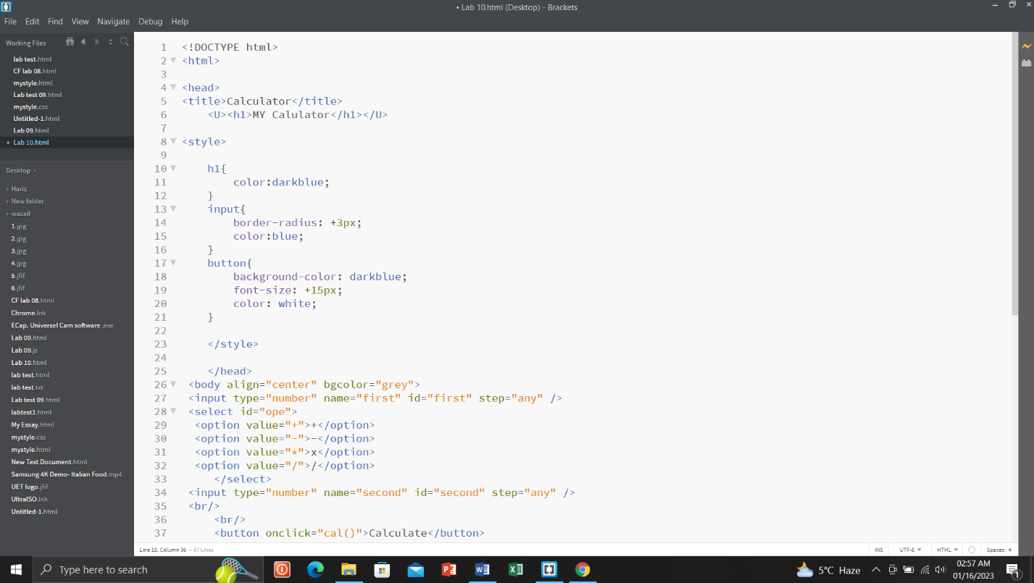
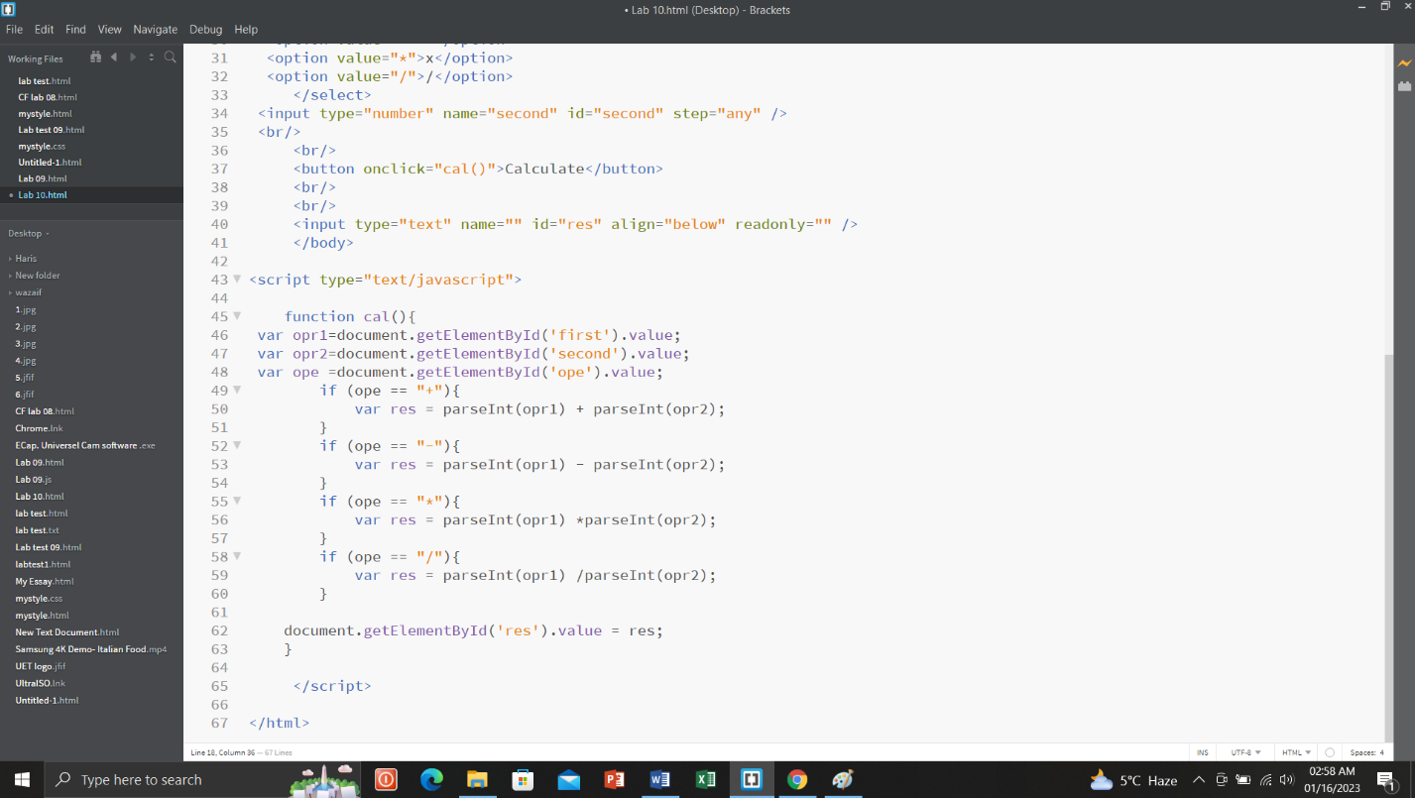

Webpage display:

Addition:
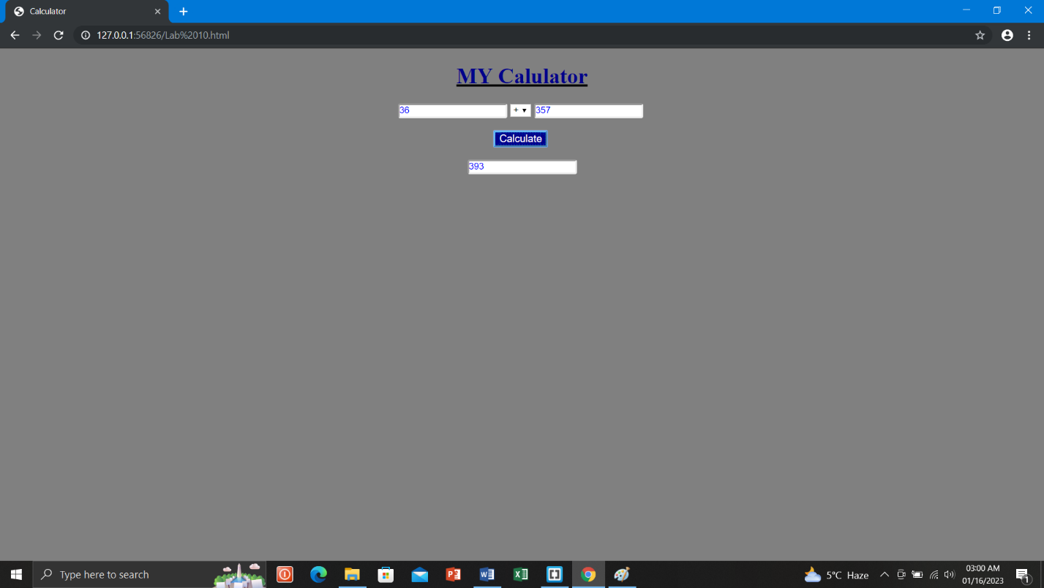

Subtraction:
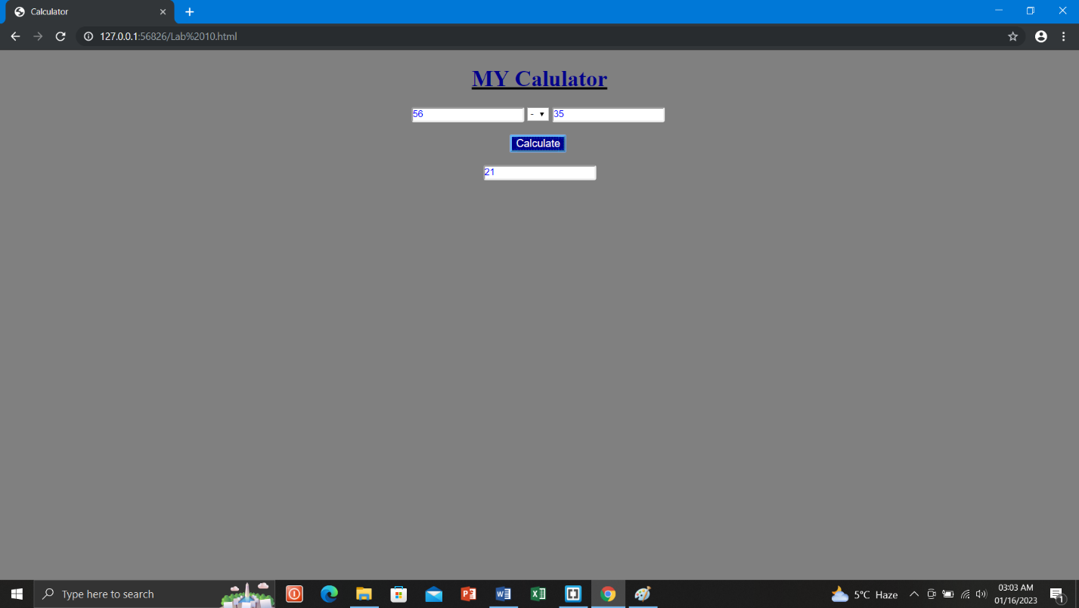

Multiplication:
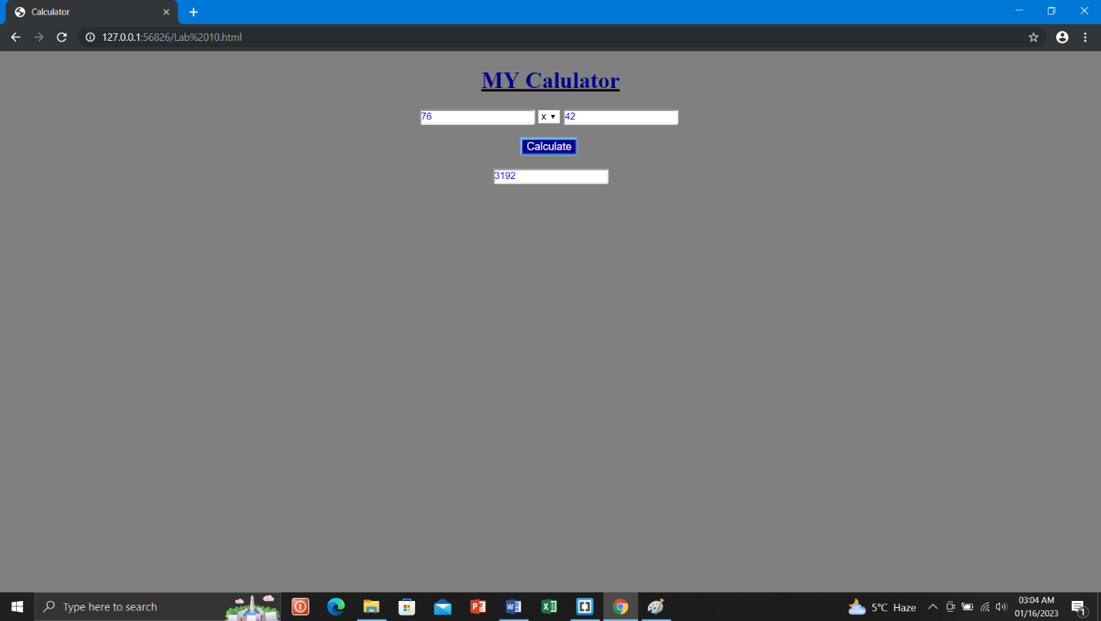

Division:
